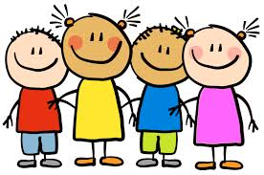
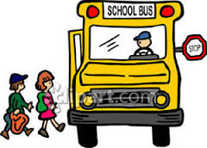
Helpful Hints for Grade 1
Please read these hints carefully and refer to as needed. This will help you and your child with their transition to Grade 1.
Bookbag Check
Please check your child’s bookbag EVERY evening for their clear file (communication bag) which may contain notices, artwork, etc. Every item sent to or from kindergarten should be placed inside this ‘file’. Encourage your child to be responsible in returning his/her communication file EVERY morning. If you send a note please remind your child to let me know.
Borrow-a-Book
Your child will bring home books from class, which should be put back in communication bag at the end of each week to trade in for new ones.
Cafeteria
Students will eat their lunch in the cafeteria every day. They may bring a lunch from home or purchase one in advance from the monthly order forms sent home. White/chocolate milk will be available to purchase daily at noon for 50 cents (cash only).
*Change of Afterschool Plan*
If at any time there is a change in your child’s afterschool plan, I will NEED a note. Your child is not permitted to go home with other children on different busses or get off at different stops. If someone is picking up your child please supply their name.
Change of Address/Phone Number
Please inform the school of any changes in personal information as soon as possible.
Clothing
All children require a pair of sneakers for inside use (preferably VELCRO, unless your child can tie laces independently). Safe footwear for outside play is also recommended. I ask that you please send in an extra pair of socks, underwear, and pants in a bag labeled with your child’s name, to be stored in their bookbag for emergencies.
Medications
Medications cannot be administered in school without proper documentations. These forms are available in the school office. A parent must come into the school and complete a form before medicine can be administered at school

Communication/Messages to Teacher
Any information for the teacher must be in written form. These should be included in the Communication Bag, or you can email me. I try my best to check email during breaks throughout the day, however if it is urgent, please phone the school.
Money
Any time money is sent to school, use an envelope/baggie marked with your child’s name and purpose.
Scholastic Book Orders
Approximately once a month I will send a book order home. There is no obligation to buy, but these are quality books at good prices. With each order we are offered items for the classroom, many at little or no cost. Orders MUST be paid for by cheque; made out to ‘Scholastic Canada’.
Snacks/Lunch
We recommend that you send only nutritious foods to school with your child. Students are welcome to bring a water bottle use daily.
This Week/Month in Grade 1
Each week you will find information about what we will be doing for the week on my school website page. Please check regularly to help support your child. http://bps.nbed.nb.ca/teacherpages
Toys
In order to avoid loss/damage of toys and tears, I request that ALL toys remain at home!

Your support is greatly appreciated. If you have any questions, concerns, or just want to check in, please do NOT hesitate to contact me. I love to hear from parents and feel that home-school communication is essential to your child’s academic growth. I am looking forward to a great year!
Thank you!
Ms. Gorman

